Project Final Report
Title:
Comparative Analysis of CNN and EfficientNet Models for Food Image Recognition on Food-101
Abstract:
This project presents a deep learning–based food image classification system using the large-scale Food-101 dataset, which includes 101 food categories and over 100,000 images. The objective of the study is to build and evaluate two different deep learning approaches: a baseline Convolutional Neural Network (CNN) and an advanced transfer learning model based on EfficientNetB0.
The dataset was preprocessed through resizing, normalization, batching, and optimized data pipelines. The baseline CNN was trained from scratch, while EfficientNetB0 was first trained in a feature extraction stage and later fine-tuned for improved performance.
Evaluation metrics—including accuracy, loss, confusion matrix, precision, recall, and F1-score—were used to assess model performance. Results show that EfficientNetB0 significantly outperforms the baseline model, achieving approximately 71.9% macro F1-score and 71.5% weighted F1-score, demonstrating its effectiveness for large-scale food image recognition tasks.
The outcomes highlight the potential of transfer learning and modern deep neural architectures in automating food classification applications such as dietary monitoring, restaurant menu recognition, and smart nutrition systems

1. Introduction

Deep learning has become a powerful tool for solving complex image classification problems. Food recognition is an important application area, especially for nutrition monitoring, dietary analysis, and smart restaurant systems. Traditional machine learning approaches struggle with large-scale food datasets because of high intra-class variability and visual similarity across categories.

This project applies deep learning techniques to the Food-101 dataset, which contains 101 classes of food images. The goal is to develop and compare a baseline CNN with a transfer-learning model (EfficientNetB0) to evaluate which approach achieves better accuracy and generalization.

The main objectives of this project are:
- To build a baseline CNN for food image classification
- To apply transfer learning using EfficientNetB0
- To fine-tune the model for improved performance
- To evaluate the models using accuracy, loss curves, confusion matrix, and classification metrics
- Which deep learning approach—baseline CNN or transfer-learning
- Research Question:
- Which deep learning approach—baseline CNN or EfficientNetB0—provides better performance for large-scale food image classification?

2. Problem Statement

Classifying food images is a challenging task due to high variability in appearance, background noise, and similarities between different food classes. Traditional machine learning approaches struggle to capture these complex patterns, especially in large-scale datasets.

The problem addressed in this project is to develop an accurate deep learning model capable of classifying images in the Food-101 dataset into 101 categories. The goal is to compare a baseline CNN with a transfer learning approach using EfficientNetB0 to determine which model achieves better performance and generalization

3. Project Architecture
- This project follows a two-stage deep learning architecture designed for large-scale food image classification.
- Baseline CNN Architecture
- A simple Convolutional Neural Network was built from scratch consisting of:
- Convolution layers with ReLU activation
- Max-Pooling layers to reduce dimensionality
- A Flatten layer
- Dense layers for classification
- Softmax output layer with 101 units (one for each food class)
- This baseline model provides a reference point to compare against advanced transfer learning methods.

- EfficientNetB0 Architecture (Transfer Learning)
- A pre-trained EfficientNetB0 (ImageNet weights) was used as the backbone:
- The top classification layer was removed
- Global Average Pooling was applied to extract features
- A Dropout layer was added for regularization
- A Dense output layer with Softmax (101 classes) was attached
- Training was done in two phases:
- Feature Extraction (base frozen)
- Fine-Tuning (unfreezing top 20 layers)

- Data Flow Pipeline
- Load Food-101 dataset using TensorFlow Datasets
- Preprocess images (resize to 224×224, normalize)
- Create TF-Dataset pipelines with batching and prefetching
- Train baseline CNN
- Train EfficientNetB0 (initial training → fine-tuning)
- Evaluate and compare models using accuracy, loss, confusion matrix, and F1-scores

4. Tools and Technologies
Software
- Programming Language: Python
- Deep Learning Framework: TensorFlow / Keras
- Additional Libraries: NumPy, Matplotlib, Seaborn, Scikit-Learn
- Development Environment: Google Colab (GPU runtime)
Hardware
- GPU: NVIDIA Tesla T4 provided by Google Colab
- CPU & RAM: Colab environment defaults
- Storage: Temporary Colab file system + Google Drive for outputs

5. Methodology

Data Collection
- The Food-101 dataset was obtained directly from TensorFlow Datasets (TFDS).
- Dataset includes 101 food classes, each with 750 training and 250 test images.

• Data Pre-Processing
- Image resizing to 224×224 pixels
- Normalization to [0,1]
- Batching (Batch Size = 32)
- Prefetching for training speed (AUTOTUNE)

• Annotation
- Labels come pre-annotated within the dataset (no manual labeling required).

• Model Training
- Baseline CNN:
  - 3 epochs quick training
  - Trained end-to-end on raw images
- EfficientNetB0 (Transfer Learning):
  - Stage 1: Feature extraction (3 epochs)
  - Stage 2: Fine-tuning top 20 layers (2 epochs)

• Evaluation metrics
- Accuracy (train & validation)
- Loss curves
- Confusion matrix
- Precision, recall, and F1-score (classification report)

• Feature Extraction
- EfficientNetB0 backbone used to extract high-level semantic features
- Global Average Pooling used instead of Flatten layer

6. Result
6.1. Comparison of Model Performance

The following table summarizes the performance of all models used in this project

Model | Train Accuracy | Validation Accuracy | F1-score (Macro Avg) | Notes
Baseline CNN | ~0.085 | ~0.11 | Very Low | Simple model for baseline comparison
EfficientNetB0 (Initial Training) | ~0.42 | ~0.71 | Good | Pretrained on ImageNet, frozen layers
EfficientNetB0 (Fine-Tuned) | ~0.60 | 0.72 | 0.716 | Best performing model

6.2.Accuracy and Loss Curves

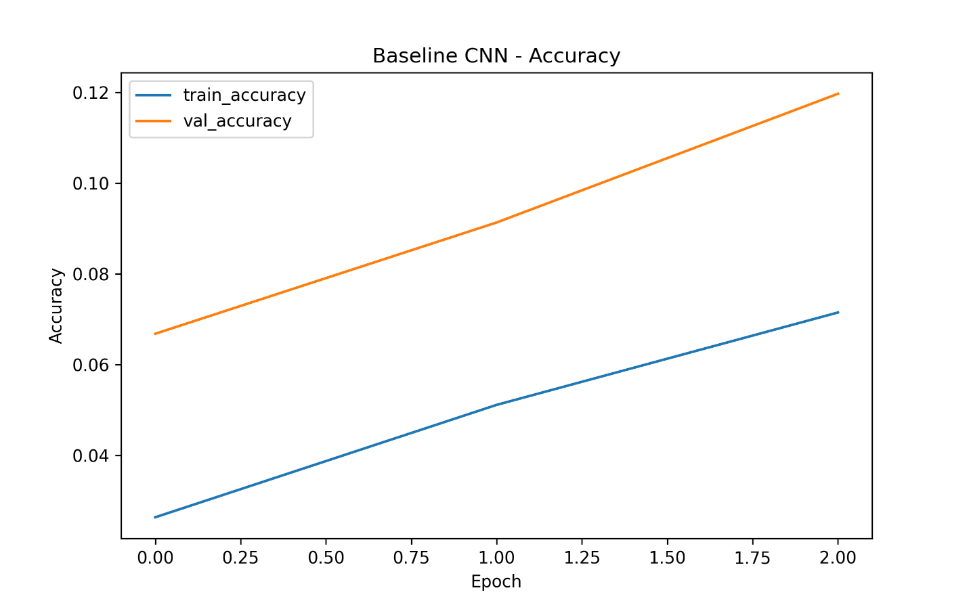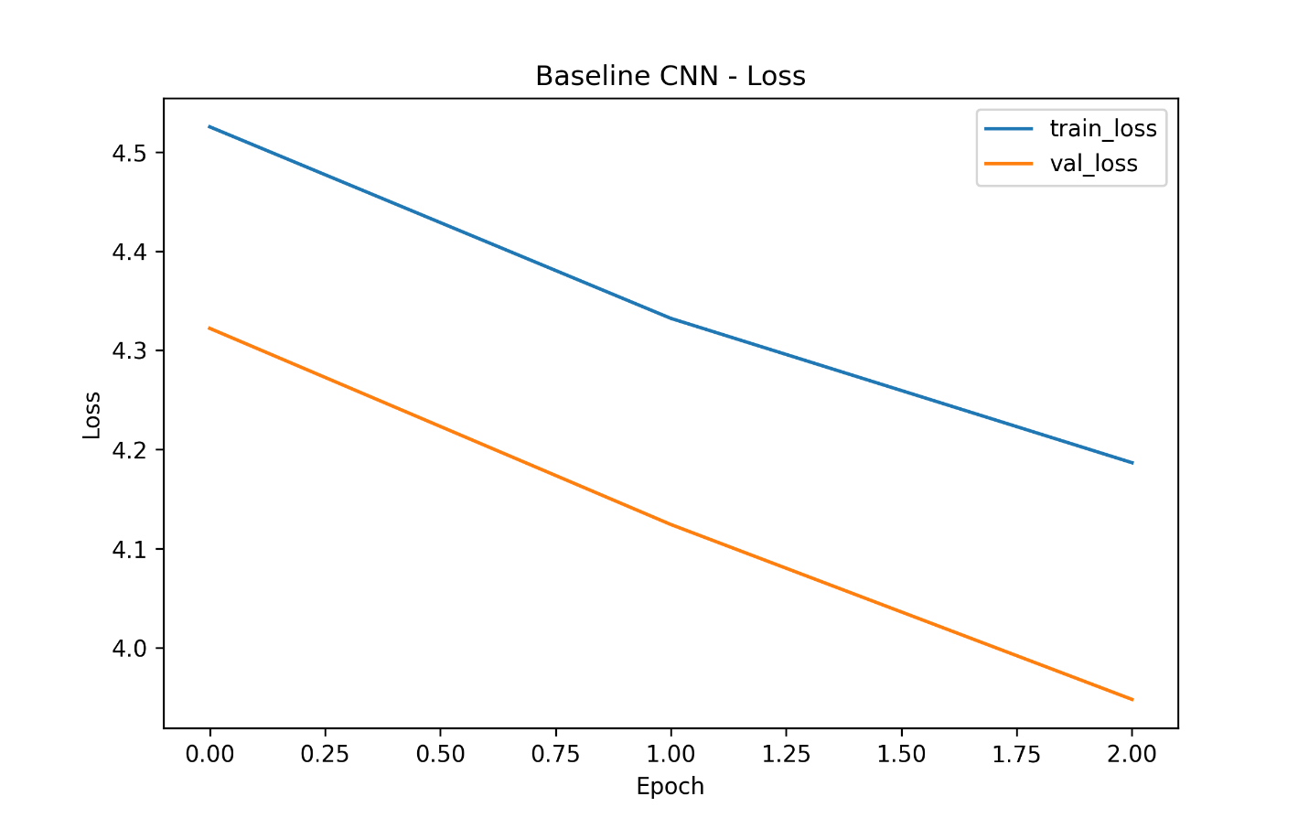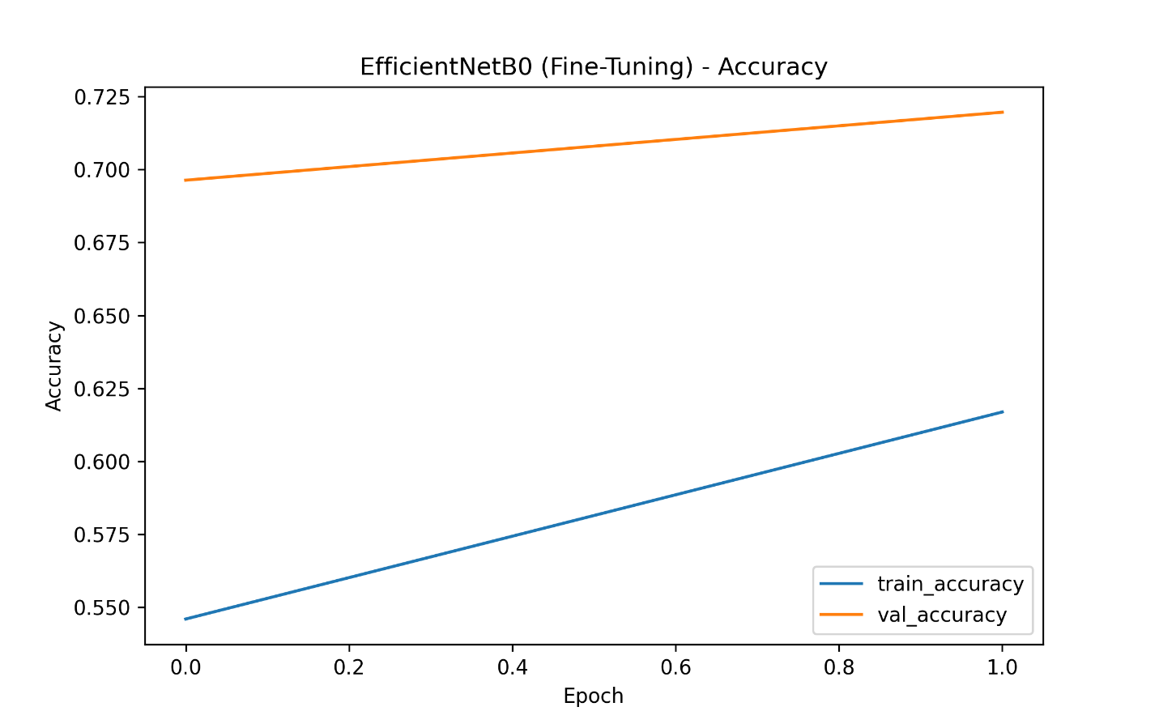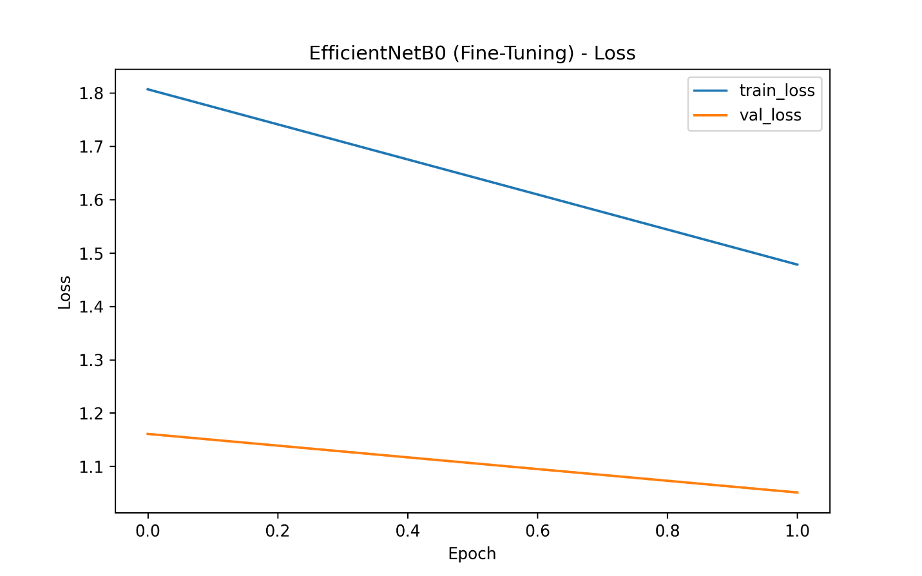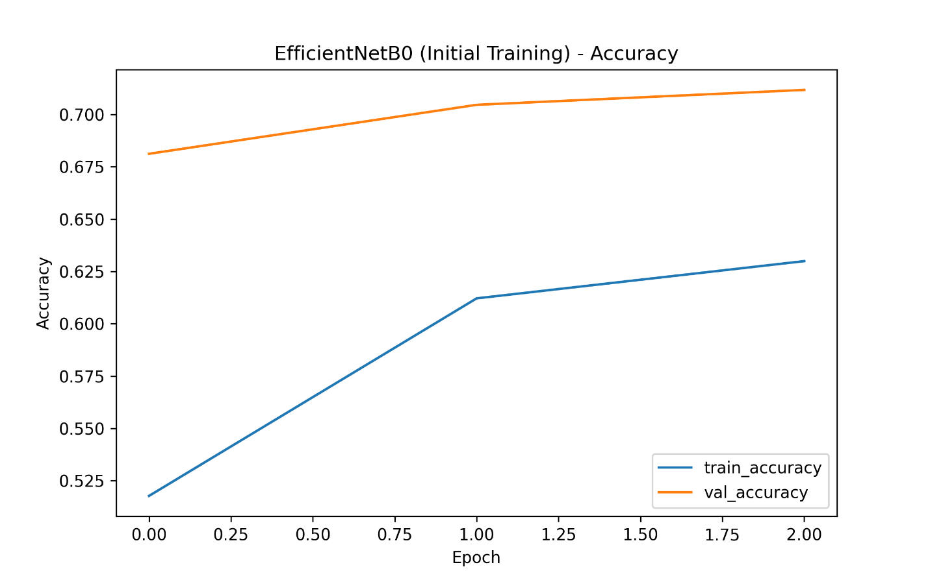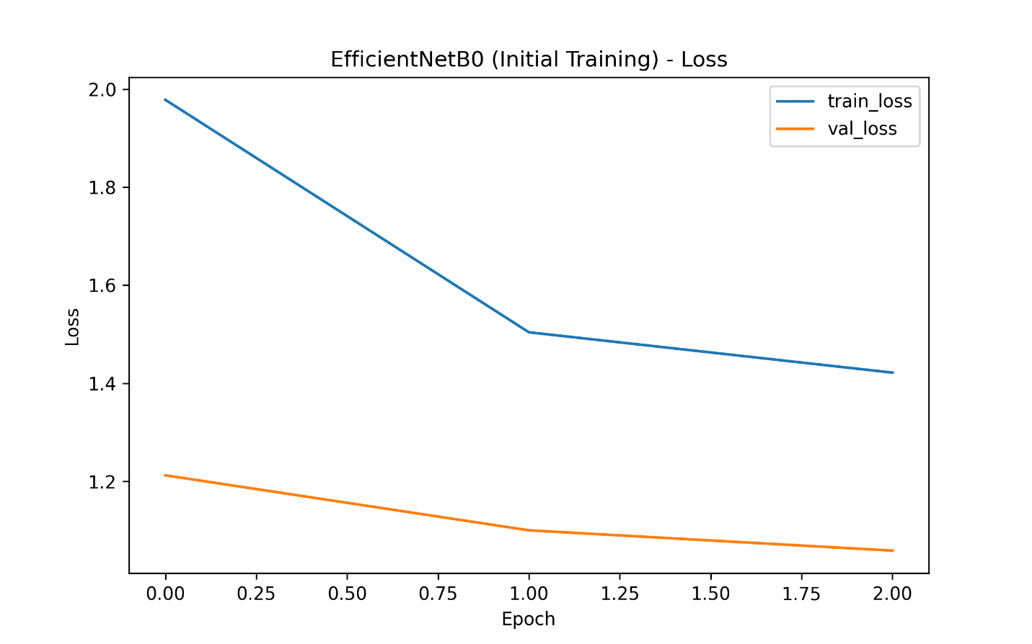

6.3 Confusion The confusion matrix shows the classification performance of the fine-tuned EfficientNetB0 model across the 101 food categories.
The strong diagonal line indicates that the model performs well on most classes, while misclassifications appear as lighter off-diagonal pointsMatrix

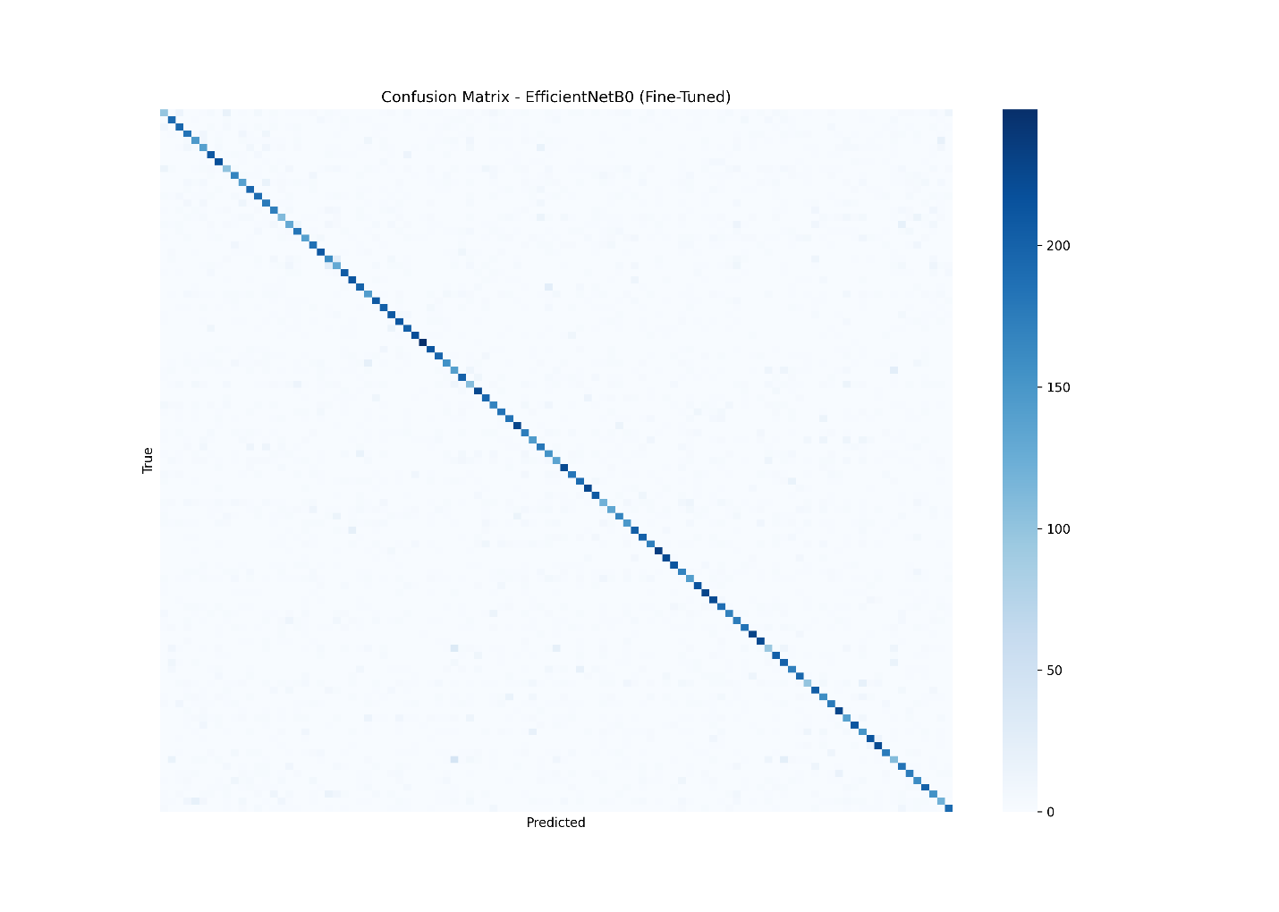

6.4 Classification Report (Precision, Recall, F1-score)

Classification Report

The classification report provides detailed performance metrics of the fine-tuned EfficientNetB0 model, including precision, recall, and F1-score for all 101 food categories.
The macro average F1-score is approximately 0.719, and the weighted average F1-score is 0.715, indicating consistent model performance across classes
Metric | Precision | Recall | F1-score
accuracy | — | — | 0.7155
macro avg | 0.7196 | 0.7155 | 0.7156
weighted avg | 0.7155 | 0.7196 | 0.7155

7. Discussion
- This project compared the performance of two different deep learning models for the Food-101 dataset: a baseline CNN and EfficientNetB0 with both initial training and fine-tuning. The results clearly show that the fine-tuned EfficientNetB0 model significantly outperforms the baseline model.
- The baseline CNN achieved very low accuracy (<15%), indicating that a simple architecture is insufficient for a large and complex dataset such as Food-101. The initial training of EfficientNetB0 improved accuracy to around 70%, due to its deeper architecture and pre-trained ImageNet weights.
- After fine-tuning the last 20 layers of EfficientNetB0, the model achieved a validation accuracy of approximately 71.9%, demonstrating the effectiveness of transfer learning. Fine-tuning allowed the model to better adapt to the domain-specific features present in the food images.
- Despite the improvements, several challenges remain.
The dataset contains 101 classes, many of which look visually similar, causing misclassifications between certain food categories. Additionally, training deep models on large datasets is computationally expensive and requires GPU resources.
- Future improvements may include hyperparameter tuning, data augmentation, using larger EfficientNet variants (e.g., B3 or B4), or applying advanced techniques such as attention mechanisms.
- Overall, the fine-tuned EfficientNetB0 demonstrates strong and reliable performance for food image classification

8. References

[1] L. Bossard, M. Guillaumin, and L. Van Gool, “Food-101 – Mining Discriminative Components with Random Forests,” European Conference on Computer Vision (ECCV), 2014.

[2] M. Tan and Q. V. Le, “EfficientNet: Rethinking Model Scaling for Convolutional Neural Networks,” International Conference on Machine Learning (ICML), 2019.

[3] A. Krizhevsky, I. Sutskever, and G. Hinton, “ImageNet Classification with Deep Convolutional Neural Networks,” Advances in Neural Information Processing Systems (NeurIPS), 2012.

[4] F. Chollet et al., “Keras Documentation.” [Online]. Available: https://keras.io/

.

[5] TensorFlow Developers, “TensorFlow Documentation.” [Online]. Available: https://www.tensorflow.org/

.

[6] Scikit-learn Developers, “Classification Report and Confusion Matrix Functions.” [Online]. Available: https://scikit-learn.org/

.

[7] Food-101 Dataset. [Online]. Available: https://www.vision.ee.ethz.ch/datasets_extra/food-101/

.

